Ideation Phase Empathize & Discover

Date | 31 October 2025
Team ID | NM2025TMID06949
Project Name | Laptop Request Catalog Item
Maximum Marks | 4 Marks

Empathy Map Canvas:
An empathy map for the Laptop Request Catalog Item focuses on the employee experience when requesting laptops an empathy map helps visualize what users say, think, do, and feel. It provides a deeper understanding of the user's needs and frustrations to guide solution design. Below is the empathy map for the Service Catalog laptop request scenario.

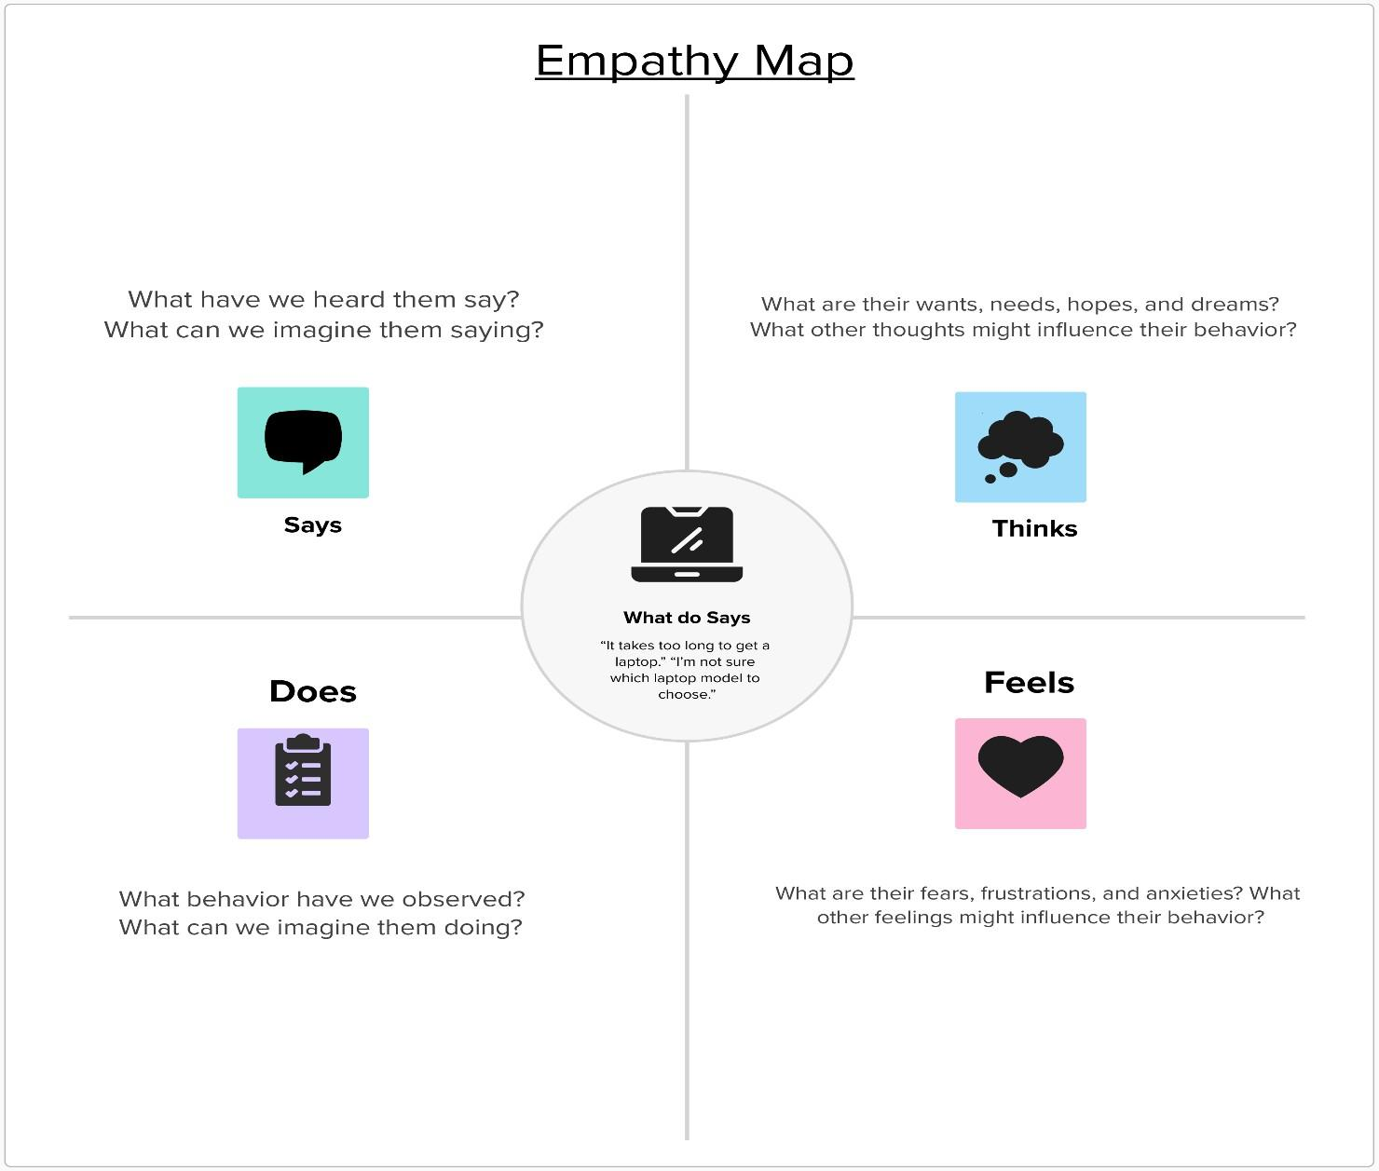
Reference: https://www.mural.co/templates/empathy-map-canvas

Laptop Service Catalog Item
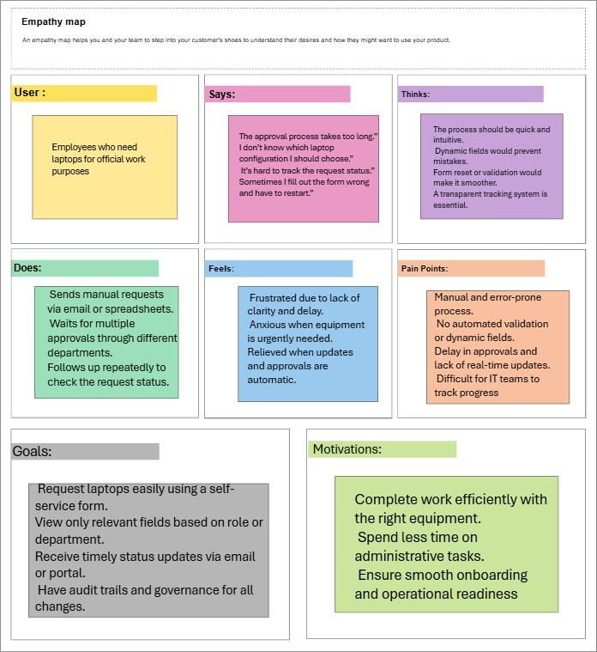

Ideation Phase
Brainstorm & Idea Prioritization Template

Date | 31 October 2025
Team ID | NM2025TMID06949
Project Name | Laptop Request Catalog Item
Maximum Marks | 4 Marks

Brainstorm & Idea Prioritization Template:
This guided project demonstrates how to create a Service Catalog Item in ServiceNow that allows employees to request laptops efficiently and accurately. The goal of this project is to streamline the laptop request process, reduce manual paperwork, and ensure all necessary approvals and configurations are handled automatically.
The project begins with the creation of a Service Catalog Item named “Laptop Request” under the IT Services category. The form includes key fields such as Laptop Type, Purpose, Department, Justification, Expected Date, and Manager Approval.
Dynamic form behavior is implemented using Catalog Client Scripts and UI Policies to display or hide fields based on user selection. For example, if a user selects “High-
Performance Laptop,” additional justification fields appear automatically.
A workflow is designed to handle approvals — when a user submits a request, it is routed to their manager for approval and then to the IT fulfillment team for processing. Once approved, a task is generated for IT staff to assign and deliver the requested laptop.
This ensures requests are processed quickly, reduces errors, and provides a centralized tracking mechanism through ServiceNow. The result is a smoother, more transparent, and automated laptop issuance process.

Step-1: Team Gathering, Collaboration and Select the Problem Statement
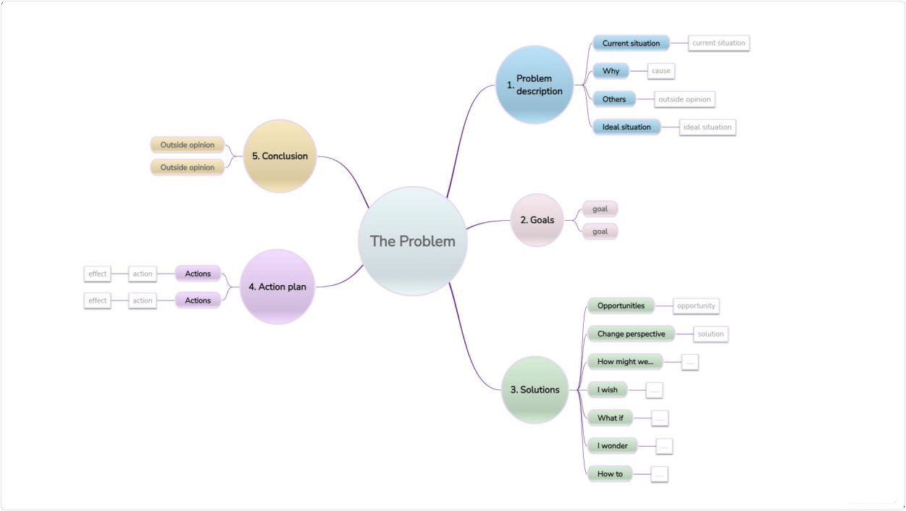
Step-2: Brainstorm, Idea Listing and Grouping
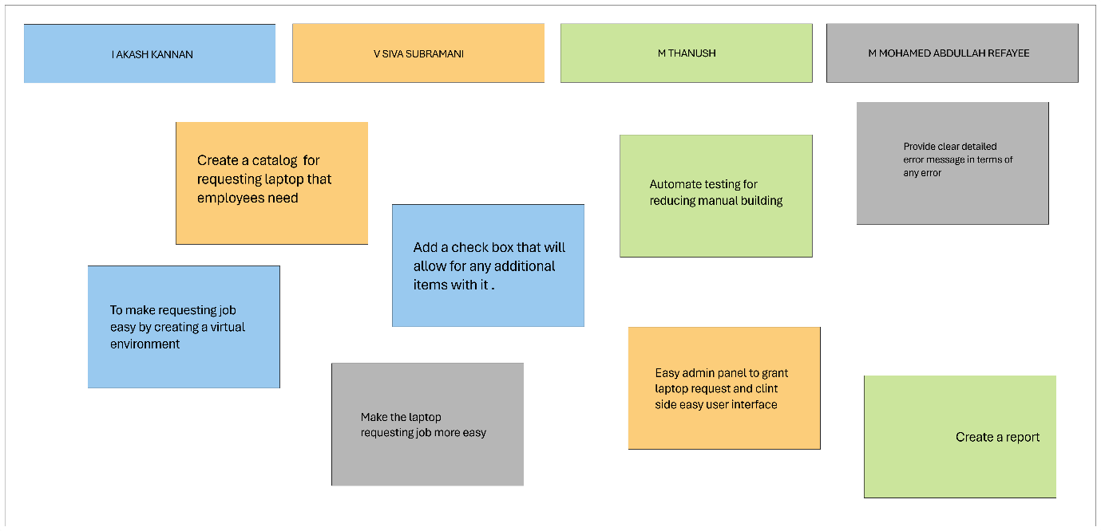

Step-3: Idea Prioritization
Idea prioritization was done to focus on the most impactful and feasible features first. The team prioritized automation and user-friendliness since these had the greatest benefit for both employees and IT staff.
- Priority 1: Automate approval workflow
- Priority 2: Dynamic field visibility
- Priority 3: Asset assignment and tracking integration
This prioritization helps simplify implementation and ensures the system addresses critical needs like efficiency and transparency.
By breaking down tasks into clear components — form creation, approval logic, and task automation — the project achieved clarity and structure. The visual workflow and well- defined form elements improved communication between development and testing teams.
Overall, the idea prioritization process ensured the successful execution of the ServiceNow Laptop Request Catalog Item, making it a scalable and maintainable solution for IT service automation.

Ideation Phase
Define the Problem Statements

Date | 31 October 2025
Team ID | NM2025TMID06949
Project Name | Laptop Request Catalog Item
Maximum Marks | 2 Marks

Problem Statement Template
Employees in the organization need a quick and efficient way to request laptops for work. The current process is manual and prone to delays, with no dynamic form behavior to guide users or ensure accurate data collection. To address this, a Service Catalog item needs to be created, allowing users to easily request a laptop, with dynamic fields, clear instructions, and additional functionality like resetting the form if needed. The solution should also ensure all changes are tracked for governance and deployment.
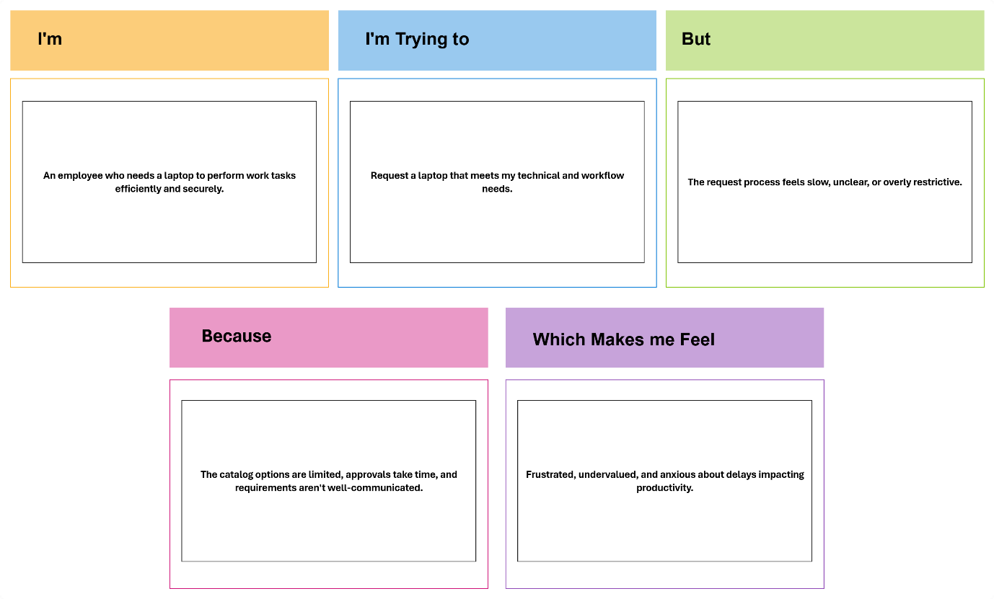

PROBLEM STATEMENTS:

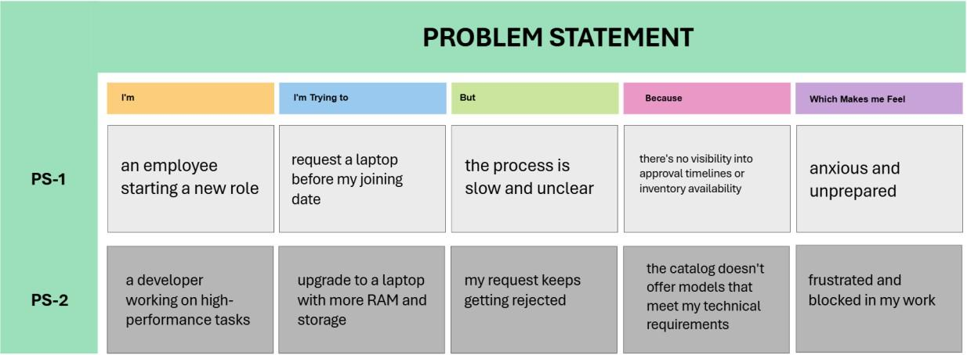
Project Design Phase-II Technology Stack (Architecture & Stack)

Date | 31 October 2025
Team ID | NM2025TMID06949
Project Name | LAPTOP REQUEST CATALOG ITEM
Maximum Marks | 4 Marks
Technical Architecture:
The Deliverable shall include the architectural diagram as below and the information as per the table1 & table 2

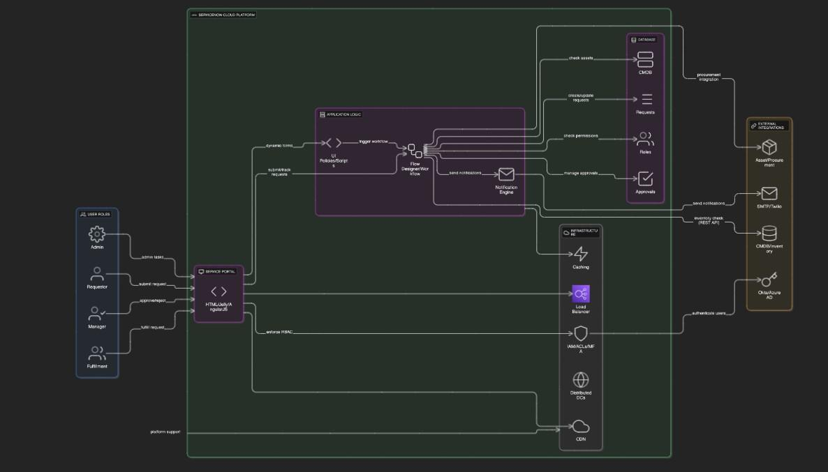
Table-1 : Components & Technologies:

S.No | Component | Description | Technology
1. | User Interface | Web-based ServiceNow Service Catalog portal to submit requests | ServiceNow UI Framework (HTML, Jelly, AngularJS inside ServiceNow)
2. | Application Logic-1 | Dynamic form behavior using UI Policies and Client  Scripts | ServiceNow Server-side scripts  (JavaScript, Glide API)
3. | Application Logic-2 | Workflow automation and approval processing | ServiceNow Flow Designer / Workflow Engine
4. | Application Logic-3 | Email notification and alert logic | ServiceNow Notification Engine
5. | Database | Stores laptop request, approval, and user data | ServiceNow CMDB, Task and Request  tables (MySQL-based backend)
6. | External API-1 | Integration to fetch laptop availability from CMDB | ServiceNow REST API or OOTB CMDB APIs
7. | Infrastructure (Server / Cloud) | ServiceNow Platform hosted on Cloud | ServiceNow Cloud SaaS Platform
Table-2: Application Characteristics:

S.No | Characteristics | Description | Technology
1. | Open-Source Frameworks | ServiceNow platform leverages open-source components like AngularJS for UI, and JavaScript  for client/server scripting. | AngularJS, JavaScript
2. | Security Implementations | Role-based access control, multi-factor authentication, encryption of data at rest and in  transit, OWASP best practices. | ServiceNow IAM, HTTPS, TLS, ACLs, OAuth2
3. | Scalable Architecture | ServiceNow’s multi-tenant cloud architecture  supports scalability with modular components and APIs following microservices principles. | ServiceNow Cloud Platform, REST APIs
4. | Availability | High availability with geographically distributed  data centers, automated failover, scheduled maintenance windows. | ServiceNow Cloud Infrastructure, Load Balancers
5. | Performance | Optimized workflows, caching mechanisms within ServiceNow, and CDN services for static assets to ensure low latency and high throughput. | ServiceNow Caching Layer, CDN (Akamaized or similar)

Project Design Phase-II
Data Flow Diagram & User Stories

Date | 31 October 2025
Team ID | NM2025TMID06949
Project Name | LAPTOP REQUEST CATALOG ITEM
Maximum Marks | 4 Marks
Data Flow Diagrams:
A Data Flow Diagram (DFD) is a traditional visual representation of the information flows within a system. A neat and clear DFD can depict the right amount of the system requirement graphically. It shows how data enters and leaves the system, what changes the information, and where data is stored.

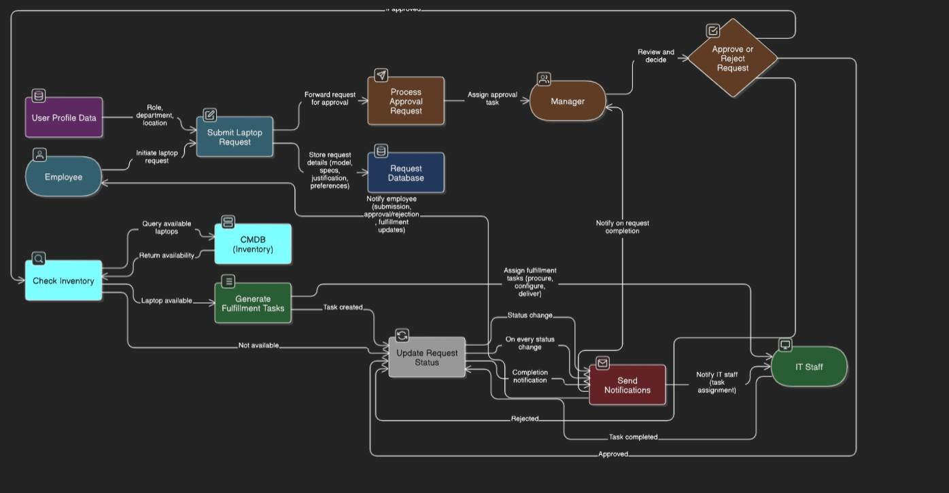
User Stories
Use the below template to list all the user stories for the product.

User Type | Functional  Requirement (Epic) | User Story Number | User Story / Task | Acceptance criteria | Priority | Release
Employee | Laptop Request Form | USN-1 | As an employee, I can access a laptop request form in ServiceNow with guided fields. | 1. Form is accessible. 2. Fields are highlighted based on role. 3. Form has a clear instruction for submission. | High | Sprint-1
Employee | Laptop Request Form | USN-2 | As an employee, I see role-based laptop recommendations based on my job title. | 1. Form is accessible. 2. Fields are highlighted based on role. 3. Form  has a clear instruction for submission. | High | Sprint-1
Employee | Form Dynamics | USN-3 | As an employee, I see dynamic fields that change based on my selections (via UI Policies). | 1. Form fields show/hide depending on selections (e.g., RAM options based on model). 2. Form adjusts for user's laptop  preference. | Medium | Sprint-1
Employee | Form Functionality | USN-4 | As an employee, I can reset the form to correct errors before submission. | 1. Form fields reset to their default state. 2. No data loss from inaccuracies. | Medium | Sprint-1
Manager | Login | USN-5 | As a manager, I can approve or reject laptop requests with comments. | 1. Email notifications sent to the approver and the requestor. 2. Approval logs are generated. 3. Manager can provide reasons for  approval/rejection. | High | Sprint-1
Employee | Form Dynamics | USN-3 | Important: This is to be revisited based on UI Policies specifics. | 1. Email notifications sent to the approver and the requestor. 2. Approval logs are generated. 3. Manager can provide  reasons for approval/rejection. | Medium | Sprint-2

User Type | Functional  Requirement (Epic) | User Story Number | User Story / Task | Acceptance criteria | Priority | Release
IT Staff | Status Tracking | USN-6 | As an employee, I can see the real-time status of my laptop request. | 1. Each request shows its status (e.g., "Pending Approval"). 2. Real-time  updates are displayed on the dashboard. | Medium | Sprint-3
IT Staff | Integration | USN-7 | As IT staff, I can see laptop availability from CMDB during request processing | 1. IT can see available models through IT’s dashboard. 2. CMDB integrates seamlessly. | Low | Sprint-3
Employee | Notifications | USN-8 | As an employee, I receive email updates on request approval or rejection. | 1. Email notifications are sent immediately after approval/rejection. 2. Notifications include the status | High | Sprint-2

Project Design Phase-II
Solution Requirements (Functional & Non-functional)

Date | 31 October 2025
Team ID | NM2025TMID06949
Project Name | LAPTOP REQUEST CATALOG ITEMs
Maximum Marks | 4 Marks

Functional Requirements:
Following are the functional requirements of the proposed solution.

FR No. | Functional Requirement (Epic) | Sub Requirement (Story / Sub-Task)
FR-1 | Laptop Request Form | Access laptop request form with guided fields Role-based laptop recommendations
FR-2 | Dynamic Form Behavior | Dynamic fields visibility based on selections (UI Policies)  Reset form to default (form functionality)
FR-3 | Approval Workflow | Manager approval with comments  Send email notifications for approval/rejection
FR-4 | Fulfillment & Status Tracking | IT staff access inventory info from CMDB Real-time status tracking for employees

Non-functional Requirements:
Following are the non-functional requirements of the proposed solution.

FR No. | Non-Functional Requirement | Description
NFR-1 | Usability | The catalog item interface should be intuitive, user- friendly, and provide dynamic guidance based on user input.
NFR-2 | Security | Access to the laptop request form and approval workflows must be role-based with strict authentication and authorization controls to ensure  data privacy.
NFR-3 | Reliability | The system should process requests and approvals accurately without data loss or downtime, ensuring consistent operation.
NFR-4 | Performance | The form loading time and workflow processing  should be efficient, with minimal latency to avoid user frustration.
NFR-5 | Availability | The laptop request service should be available  99.9% of the time, with scheduled maintenance windows communicated in advance.
NFR-6 | Scalability | The solution must support future expansion such as additional user roles, new laptop models, and integration with other systems without significant  rework.

Project Design Phase Solution Architecture

Date | 31 October 2025
Team ID | NM2025TMID06949
Project Name | LAPTOP REQUEST CATALOG ITEM
Maximum Marks | 4 Marks

Solution Architecture:

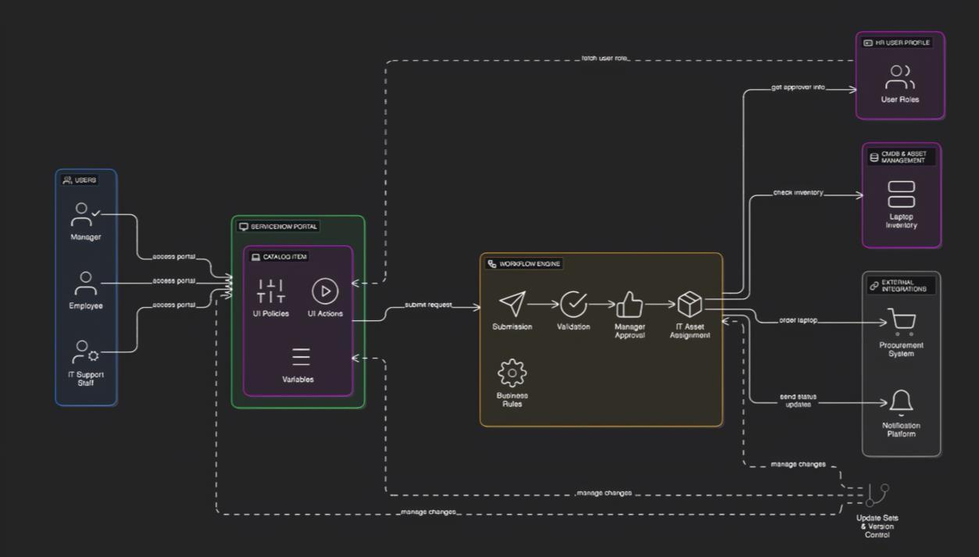
Project Design Phase Problem – Solution Fit Template

Date | 31 October 2025
Team ID | NM2025TMID06949
Project Name | LAPTOP REQUEST CATALOG ITEM
Maximum Marks | 2 Marks

Problem – Solution Fit Template:
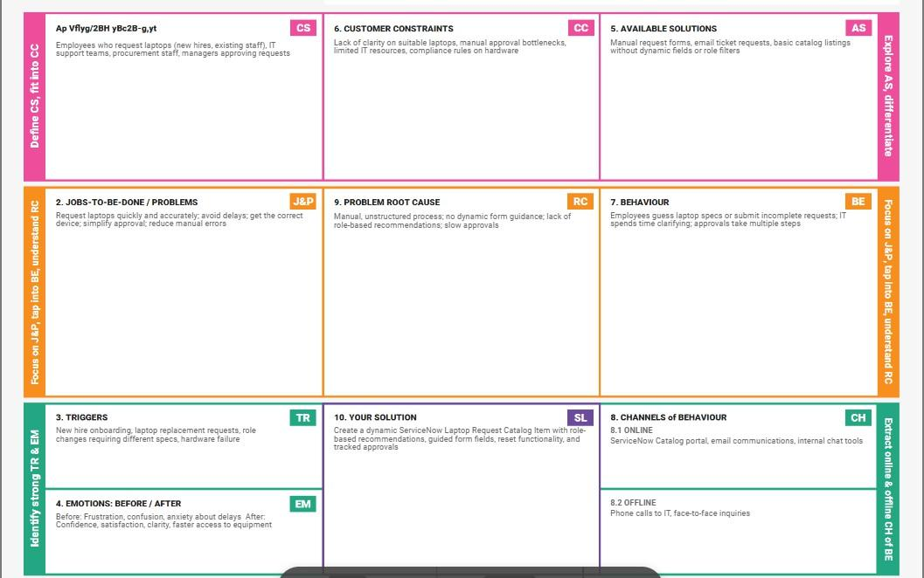

Project Design Phase Proposed Solution Template

Date | 31 October 2025
Team ID | NM2025TMID06949
Project Name | LAPTOP REQUEST CATALOG ITEM
Maximum Marks | 2 Marks

Proposed Solution Template:

S.No. | Parameter | Description
1. | Problem Statement (Problem to be solved) | Employees face delays and confusion in requesting laptops due to a manual, error-  prone process with no dynamic guidance or automation.
2. | Idea / Solution description | Develop a dynamic ServiceNow Service Catalog Item for laptop requests with role-based recommendations, UI policies for guided form  behavior, and automated approval workflows.
3. | Novelty / Uniqueness | Unique integration of dynamic UI policies and role-specific laptop suggestions within ServiceNow, reducing user error and  streamlining IT processes.
4. | Social Impact / Customer Satisfaction | Improves employee onboarding and productivity by ensuring faster, accurate laptop delivery; boosts satisfaction for both users and  IT staff through an intuitive interface.
5. | Business Model (Revenue Model) | Cost savings through reduced IT support time and error handling; potential for licensing the solution to other organizations using  ServiceNow.
6. | Scalability of the Solution | Easily scalable by adding new laptop models, roles, or approval rules in ServiceNow; deployable across multiple instances or  organizations via Update Sets.

Project Planning Phase

Project Planning Template (Product Backlog, Sprint Planning, Stories, Story points)

Date | 31 October 2025
Team ID | NM2025TMID06949
Project Name | LAPTOP REQUEST CATALOG ITEM
Maximum Marks

Product Backlog, Sprint Schedule, and Estimation (4 Marks)

Sprint | Functional  Requirement (Epic) | User Story  Number | User Story / Task | Story Points | Priority | Team  Members
Sprint-1 | Laptop Request Form | USN-1 | As an employee, I can access a laptop request form in ServiceNow with guided fields. | 3 | High | Developer, UX
Sprint-1 | Laptop Request Form | USN-2 | As an employee, I see role-based laptop recommendations based on my job title. | 2 | High | Developer
Sprint-2 | Form Dynamics | USN-3 | As an employee, I see dynamic fields that change based on my selections (via UI Policies) | 3 | Medium | Developer, Tester
Sprint-1 | Form Functionality | USN-4 | As an employee, I can reset the form to correct errors before submission. | 1 | Medium | Developer
Sprint-1 | Approval Workflow | USN-5 | As a manager, I can approve or reject laptop requests with comments. | 2 | High | Developer, IT
Sprint-3 | Status Tracking | USN-6 | As an employee, I can see the real-time status of my laptop request. | 2 | Medium | Developer, UX
Sprint-3 | Integration | USN-7 | As IT staff, I can see laptop availability from CMDB during request processing | 3 | Low | Developer, IT
Sprint-2 | Notifications | USN-8 | As an employee, I receive email updates on request approval or rejection. | 1 | High | Developer

Project Tracker, Velocity & Burndown Chart: (4 Marks)

Sprint | Total Story Points | Duration | Sprint Start Date | Sprint End Date (Planned) | Story Points  Completed (as on Planned End Date) | Sprint Release Date (Actual)
Sprint-1 | 7 | 4 Days | 13 OCT 2025 | 16 OCT 2025 | 7 | 16 OCT 2025
Sprint-2 | 5 | 4 Days | 17 OCT 2025 | 20 OCT 2025 | 5 | 20 OCT 2025
Sprint-3 | 5 | 5 Days | 21 OCT 2025 | 25 OCT 2025 | 5 | 25 OCT 2025

Velocity:
Sprint-1: Completed 7 story points in 4 days, with a higher velocity due to focused work on core functionalities.
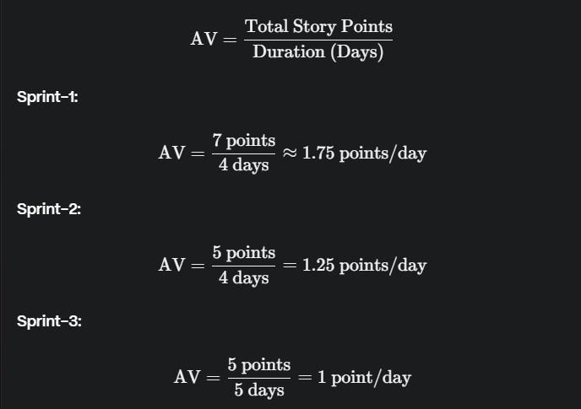
Sprint-2: Completed 5 story points in 4 days, slightly lower velocity due to more complex tasks.
Sprint-3: Completed 5 story points in 5 days, the lowest velocity due to additional time required for testing and integrations.
Project Management Definitions for
ServiceNow Laptop Request Catalog Item

Key Definitions
A Sprint: Fixed period or duration in which a team works to complete a set of tasks
An Epic: A big task or project that is too large to complete in one sprint. It is broken down into smaller tasks (stories) that can be completed over multiple sprints.
A Story: A small task. It is part of an Epic.
A Story Point: A number that represents how much effort a story takes to complete. (usually in form of Fibonacci series)

Story Point Complexity Scale
1 point: Very Easy task (e.g., adding a simple variable to form)
2 points: Easy task (e.g., creating basic UI policy)
3 points: Moderate task (e.g., implementing workflow notifications)
5 points: Difficult task (e.g., complex dynamic logic or integrations)

Sprint Details

Sprint 1:

Catalog Item Foundation
- Create basic laptop request form structure: 2
- Add essential variables (model, RAM, etc.): 1

Dynamic Form Logic
- Implement role-based laptop recommendations: 2
- Create UI policy for showing/hiding fields: 2

Sprint 2:

Workflow & Approvals
- Configure manager approval workflow: 3
- Set up email notifications: 2

Sprint 3:

Fulfillment & Integration
- Create IT fulfillment tasks: 2
- Integrate with CMDB for inventory check: 3

Velocity Calculation

Total Story Points:
- Sprint 1 = 7
- Sprint 2 = 5
- Sprint 3 = 5
- Total = 17

Velocity = Total Story Points Completed / Number of Sprints
- Total Story Points = 7 + 5 + 5 = 17
- Number of Sprints = 3
- Velocity = 17 ÷ 3 = 5.67

Your team's velocity is 5.67 Story Points per Sprint.
Note: This velocity means your team completes approximately 5-6 story points in each sprint, which helps in planning future work and setting realistic expectations for delivery timelines.# Project Management Definitions for ServiceNow Laptop Request Catalog Item

Key Definitions
A Sprint: Fixed period or duration in which a team works to complete a set of tasks
An Epic: A big task or project that is too large to complete in one sprint. It is broken down into smaller tasks (stories) that can be completed over multiple sprints.
A Story: A small task. It is part of an Epic.
A Story Point: A number that represents how much effort a story takes to complete. (usually in form of Fibonacci series)

Story Point Complexity Scale
1 point: Very Easy task (e.g., adding a simple variable to form)
2 points: Easy task (e.g., creating basic UI policy)
3 points: Moderate task (e.g., implementing workflow notifications)
5 points: Difficult task (e.g., complex dynamic logic or integrations)

Sprint Details

Sprint 1:

Catalog Item Foundation
- Create basic laptop request form structure: 2
- Add essential variables (model, RAM, etc.): 1

Dynamic Form Logic
- Implement role-based laptop recommendations: 2
- Create UI policy for showing/hiding fields: 2

Sprint 2:

Workflow & Approvals
- Configure manager approval workflow: 3
- Set up email notifications: 2

Sprint 3:

Fulfillment & Integration
- Create IT fulfillment tasks: 2
- Integrate with CMDB for inventory check: 3

Velocity Calculation

Total Story Points:
- Sprint 1 = 7
- Sprint 2 = 5
- Sprint 3 = 5
- Total = 17

Velocity = Total Story Points Completed / Number of Sprints
- Total Story Points = 7 + 5 + 5 = 17
- Number of Sprints = 3
- Velocity = 17 ÷ 3 = 5.67

My team's velocity is 5.67 Story Points per Sprint.
Laptop Request Catalog Item

Date | 31 October 2025
Team ID | NM2025TMID06949
Project Name | Laptop Request Catalog Item
Maximum Marks | 4 Marks

Introduction
Employees in the organization need a quick and efficient way to request laptops for work. The current process is manual and prone to delays, with no dynamic form behavior to guide users or ensure accurate data collection. To address this, a Service Catalog item needs to be created, allowing users to easily request a laptop, with dynamic fields, clear instructions, and additional functionality like resetting the form if needed. The solution should also ensure all changes are tracked for governance and deployment.

Key Features
- Update Set : Create or select an update set to track changes.
- Service Catalog Item: Create the laptop request item in the Service Catalog.
- UI Policy: Define UI policies to control form behavior
- UI Action: Add buttons or links (UI actions) for user interactions.
- Export Update Set: Export the update set after completing configurations.
- Login to Another Instance: Access a different ServiceNow instance
- Testing: Test the catalog item to ensure all functionality works as expected.
- Conclusion: Final thoughts or wrap-up.
Pre-requisites
- Active ServiceNow Personal Developer Instance (PDI) obtained from developer.servicenow.com.
- Basic familiarity with:
  - ServiceNow navigation and configuration
  - Tables, forms, and related lists
  - Business rules and Flow Designer
- GitHub or other repository (optional) for maintaining documentation and exported update sets

Requirements Functional Requirements
  - The system must allow the creation of an update set to track changes made for the catalog item.
  - Users should be able to create a new catalog item specifically for laptop requests.
  - The item should include relevant fields such as model, purpose, justification, and approval.
  - Show/hide fields based on conditions.
  - Make fields mandatory or read-only.
  - Add actions like submit, reset, or cancel to the catalog item form for user interaction.
  - Ability to export the completed update set for transfer to another instance.

Non-Functional Requirements
  - The catalog item form should load within 2 seconds.
  - Request submission should be processed without noticeable delay.
  - The catalog item form should be user-friendly and intuitive.
  - Field labels and help text must be clear and meaningful.
  - Only authorized users (e.g., IT Admins or Catalog Admins) should be able to create or modify the catalog item.
  - Data in the form should be validated to prevent injection attacks.

Phases of the Project Ideation Phase
The Ideation Phase identifies the need to automate laptop requests using ServiceNow. Stakeholders discuss challenges with manual processes and propose a catalog item with dynamic forms and approvals. Key requirements are outlined, feasibility is assessed, and the idea is approved to move forward.

Requirement Analysis Phase
  - Identify required fields (e.g., laptop model, justification).
  - Define user roles (requester, approver, fulfiller).
  - Document functional and non-functional requirements.
  - Set business rules and approval conditions.
  - Plan request workflow (submit → approve → fulfill).
  - Use ServiceNow components like Catalog Item, UI Policies, and Update Sets.
  - Validate and finalize requirements with stakeholders.

Project Planning Phase
The team executed these milestones:
- ServiceNow Instance Setup
  - Signed up at developer.servicenow.com and requested a Personal Developer Instance (PDI)
  - Filled necessary details; received instance access credentials via email
  - Logged in and prepared the instance for development.
- Creation of Local Update Set
- Access Navigation
  - Open ServiceNow and go to All → Update Sets.
- Choose Local Update Sets
  - Select Local Update Sets under the System Update Sets module.
- Create New Update Set
  - Click New to open the update set form.
  - Enter a meaningful name, e.g., "Laptop Request".
- Save and Submit
  - Click Submit to save the new update set.
- Activate the Update Set
  - After submission, click Make Current.
  - This ensures all your changes are tracked under this update set.
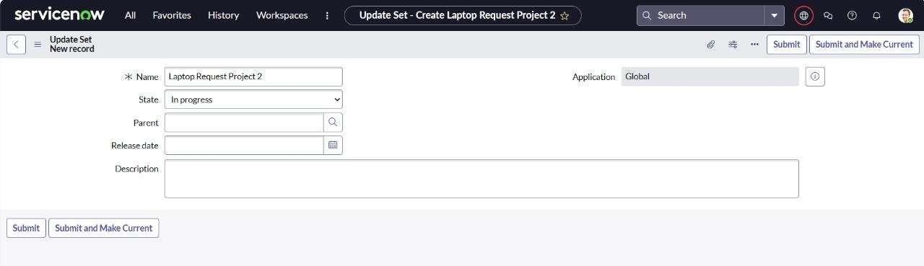

Create Service Catalog Item
- Open service now.
- Click on All >> service catalog
- Select maintain items under catalog definitions
- Click on New.
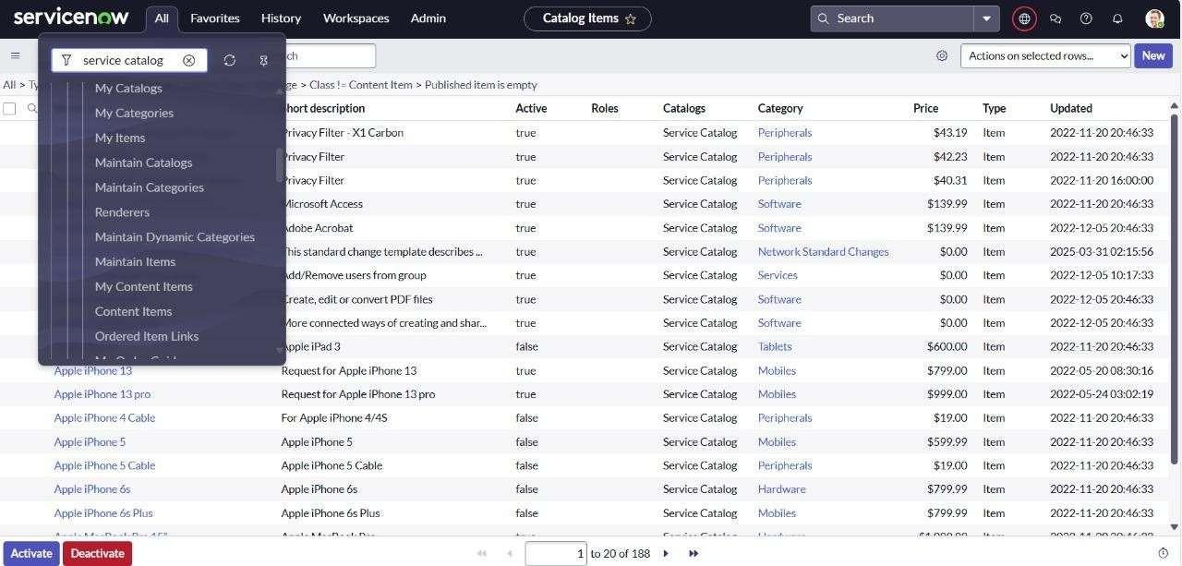
Fill the following details to create a new catalog item Name: Laptop Request
Catalog: service Catalog Category: Hardware
Short Description: Use this item to request a new laptop Click on ‘SAVE’
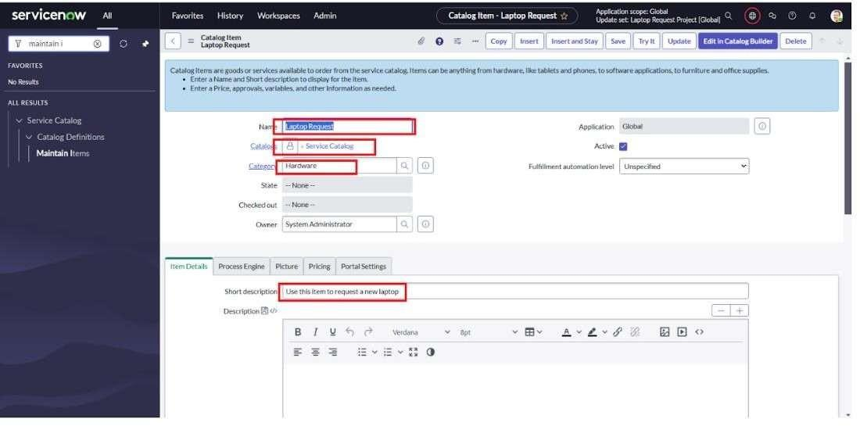

Add variables Step1:
  - After saving the catalog item form scroll down and click on variable(related list)
  - Click on new and enter the details as below
    - Variable 1:Laptop Model Type: Single line text Name: laptop_model Order:100
  - Click on submit
Again click on new and add Remaining variables in the above process
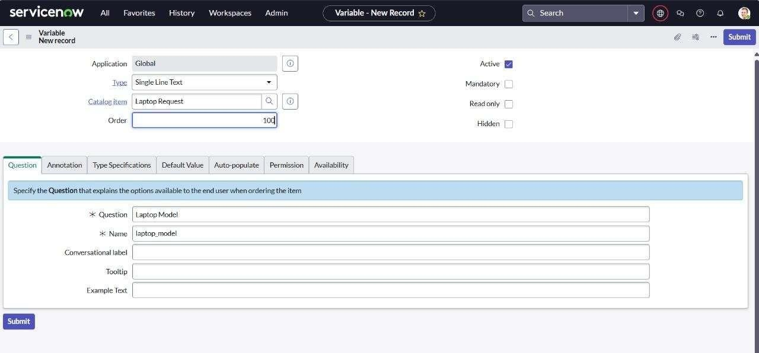

- Variable 2:Justification Type: Multi line text Name: justification Order:200
- Variable 3:Additional Accessories Type: Checkbox
Name: additional_accessories Order:300
- Variable 4: Accessories Details Type: Multi line text Name:accessories_details Order:400
Step2:
  - After adding above variable which are added to newly created catalog item
  - Then save the catalog item form
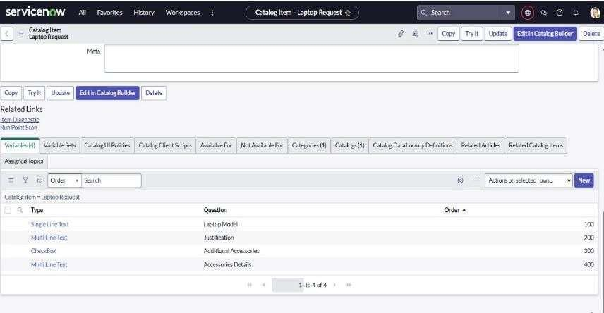

Create Catalog Ui policies
- Click on all>> search for service catalog
- Select maintain item under catalog definition
- Search for ‘laptop request’ which is created before
- Select ‘laptop request’ and scroll down click on “Catalog Ui policies”
- In the catalog ui policies related list tab click on new
- Give short description as: show accessories details
- Set the Catalog Condition in the related list tab ‘when to apply’ [field: additional_ accessories, operator: is, value: true]
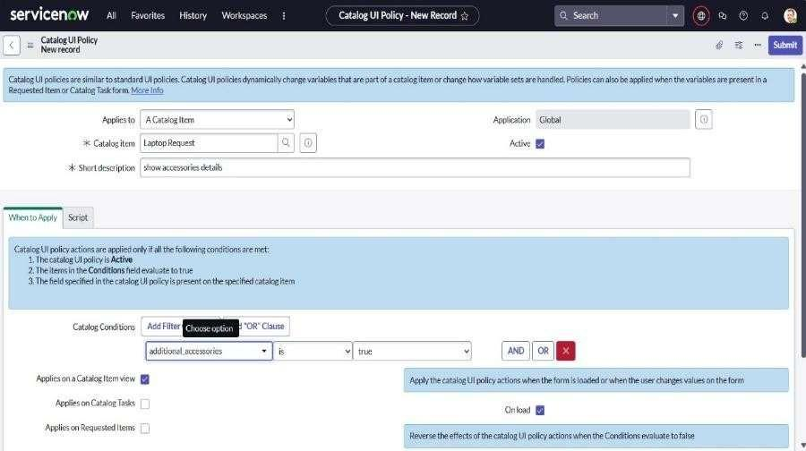

- Click on save.(do not click on submit)
- Scroll down and select ‘catalog ui action’
- Then click on new button
- Select variable name as: accessories_details
Order:100 Mandatory: True Visible : True
- Click on save and again click save button of the catalog ui policy form.
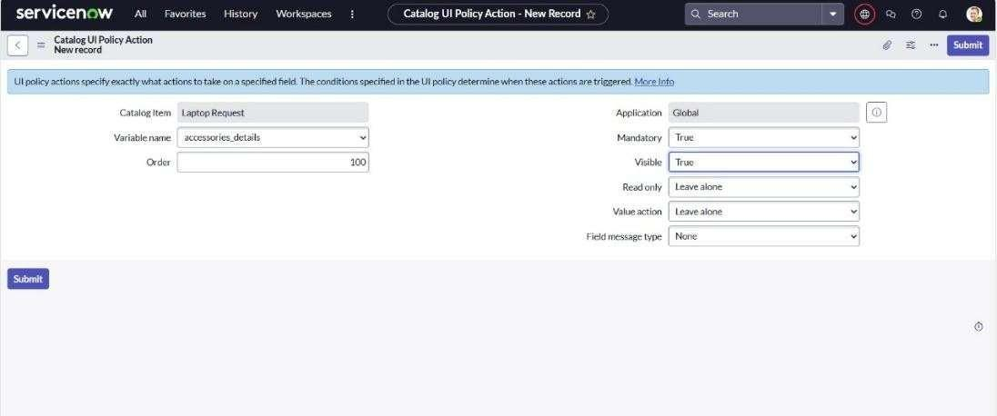
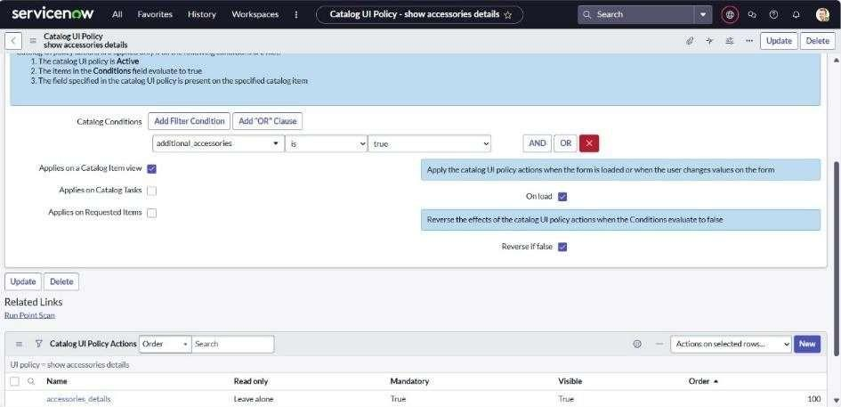

Exporting changes to another instances
  - Click on All >> search for update sets
  - Select local update set
  - Select created update set i.e. ‘Laptop Request Project’
  - Set the state to ‘Complete’
  - In the related list Update tab, updates are visible which we perform under this update set.
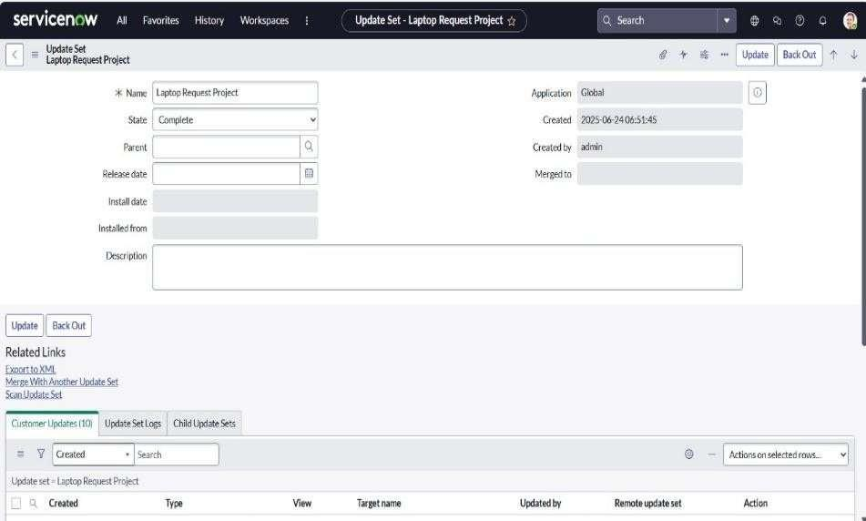
  - Click on export to XML ,it download one file

Retrieving the update set
- Open another instance in incognito window
- Login with credentials
- Click on all>> search for update sets
- Select “Retrieved update set” under system update set
- It open retrieved update set list and scroll down
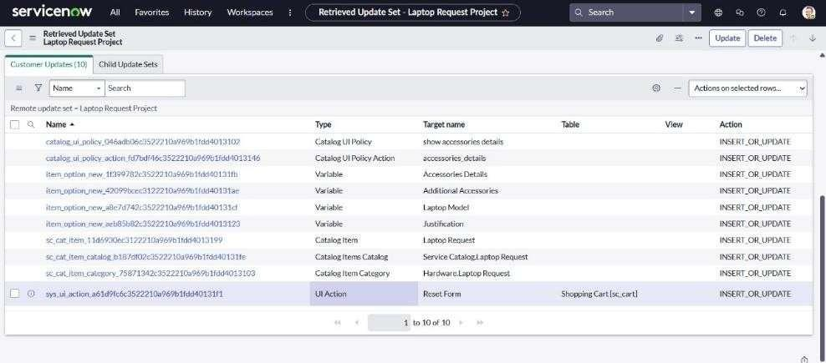
- Click on Import update set from XML
- Upload the downloaded file in XML file
- Click on Upload and it gets uploaded.
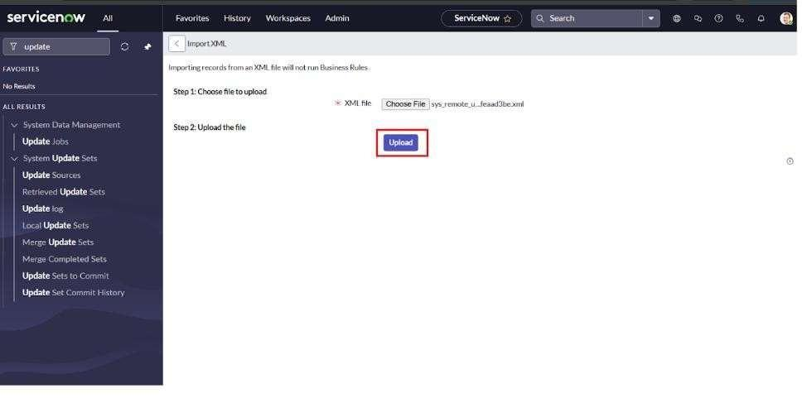

- Open retrieved update set ‘laptop request project’
- Click on preview update set
- And click on commit update set
- And also see the related tab updates
- After commiting update set in this instance we get all updates which are done in the previous instance.
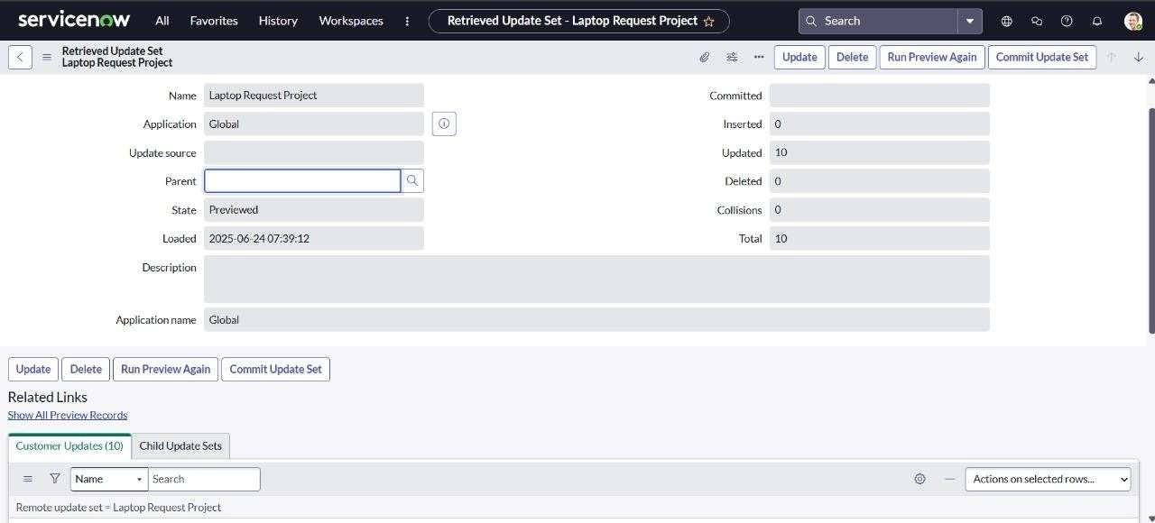
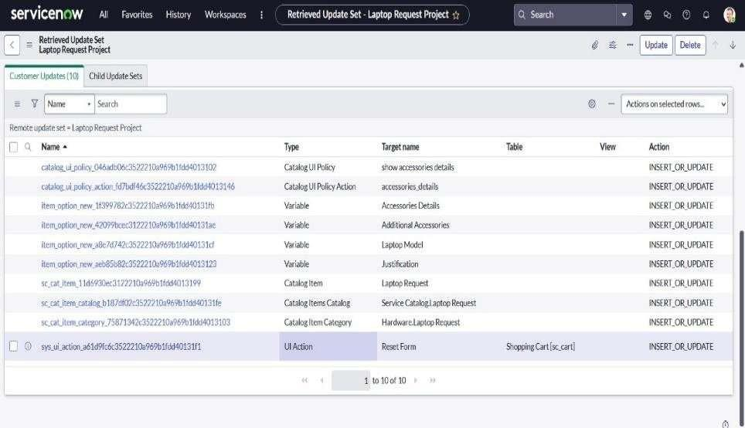

Test Catalog Item
- Search for service catalog in application navigator in target instance
- Select catalog under service catalog
- Select hardware category and search for ‘laptop request’ item
- Select laptop request item and open it
- It shows three variables only.
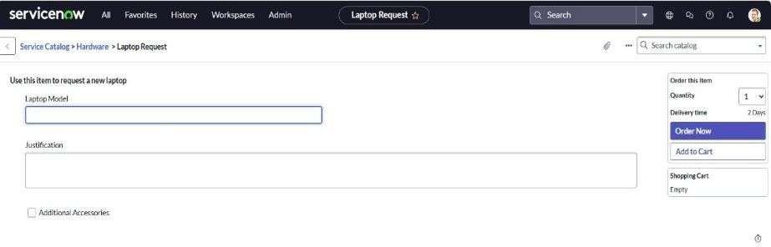

- As per our scenario, when we click on additional accessories checkbox then accessories details fields is visible and that should be mandatory
- Now see the results,it fulfills our requirements.
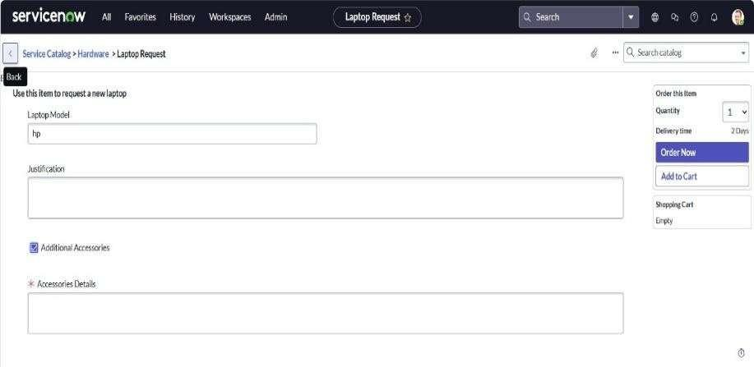

Output: https://drive.google.com/file/d/1cXZv3boBmkt6fATx1vDW0EmMqDA0_eZx/view?usp=sharing Conclusion:
The Laptop Request Catalog Item project successfully streamlines the process of requesting laptops within the organization by leveraging ServiceNow's Service Catalog capabilities. Through the implementation of a dynamic catalog item, the project ensures that users have an intuitive and user-friendly interface, reducing errors and improving efficiency.This project demonstrates how ServiceNow can be used to replace manual, error-prone processes with automated, efficient, and user-centric solutions. It not only improves service delivery but also enhances employee satisfaction by providing a modern and streamlined request experience.

